**COAL LAB# 06**

**Task 1**

INCLUDE Irvine32.inc  
.data   
prompt BYTE "Generating 20 random integers between 0 and 990",0  
.code  
MAIN PROC  
mov eax, black + (green*16)  
call SetTextColor  
call crlf  
call clrscr  
mov edx,OFFSET prompt  
call writeString  
call crlf  
mov eax,991  
mov ecx,20  
mov edx,0  
inc dh  
generate:  
call Gotoxy  
call RandomRange  
call WriteDec  
mov eax,5  
call delay  
mov eax,991  
call crlf  
add dh,1  
add dl,2  
loop generate  
exit  
MAIN ENDP  
END MAIN

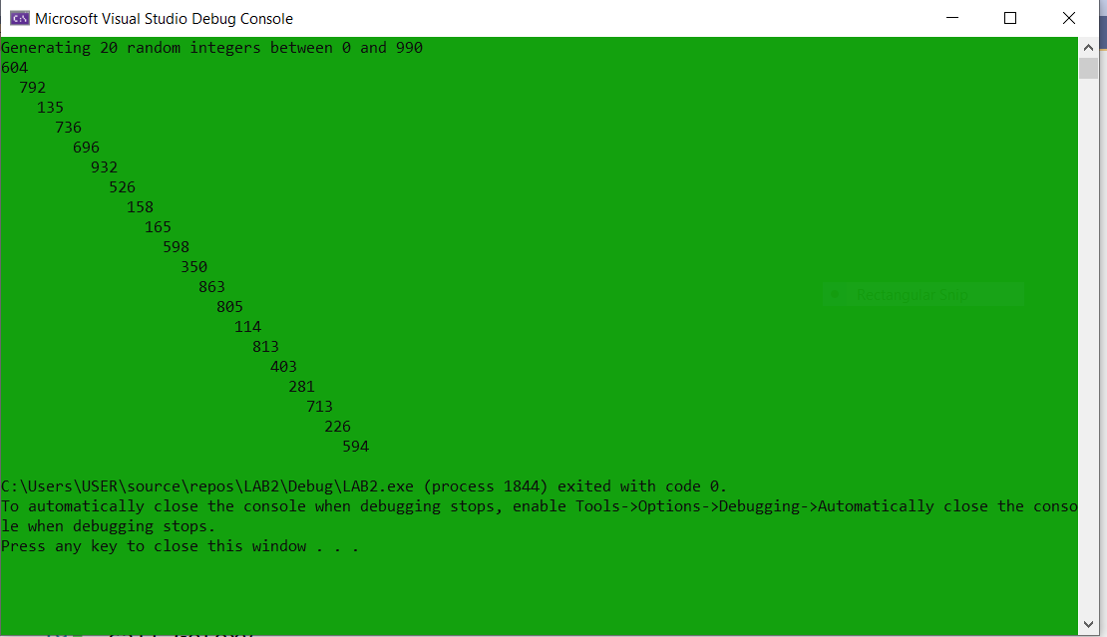

**Task 4**

INCLUDE Irvine32.inc

BUFFER_SIZE = 501

.data

buffer BYTE BUFFER_SIZE DUP(?)

filename BYTE "Fibo.txt",0

fileHandle HANDLE ?

stringLength DWORD ?

bytesWritten DWORD ?

str2 BYTE "Bytes written to file [Fibo.txt]:",0

str3 BYTE "Enter up to 8 characters and press"

BYTE "[Enter]: ",0dh,0ah,0

.code

main PROC

; Create a new text file.

mov edx,OFFSET filename

call CreateOutputFile

mov fileHandle,eax

; Ask the user to input a string.

mov edx,OFFSET str3 ; "Enter upto ...."

call WriteString

mov ecx,BUFFER_SIZE ; Input a string

mov edx,OFFSET buffer

call ReadString

mov stringLength,eax ; counts chars entered

; Write the buffer to the output file.

mov eax,fileHandle

mov edx,OFFSET buffer

mov ecx,stringLength

call WriteToFile

mov bytesWritten,eax ; save return value

call CloseFile

; Display the return value.

mov edx,OFFSET str2 ; "Bytes written"

call WriteString

mov eax,bytesWritten

call WriteDec

call Crlf

exit

main ENDP

END main

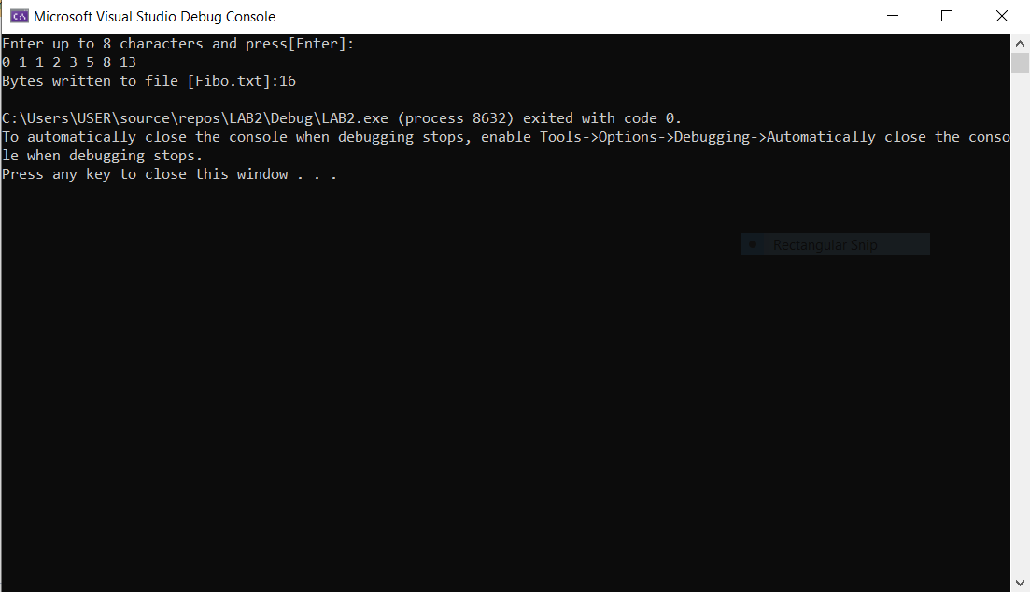

**Task 5**

INCLUDE Irvine32.inc

.data

i DWORD 5

j DWORD 6

starsCount DWORD 1

STARS DWORD "*",0

.code

MAIN PROC

mainLoop:

mov ecx,i

mov ebx,ecx

mov eax,j

sub eax,starsCount

mov ecx,eax

spaceLoop:

mov edx,OFFSET SPACE

call WriteString

LOOP spaceLoop

mov ecx,starsCount

starLoop:

mov edx,OFFSET STARS

call WriteString

LOOP starLoop

inc starsCount

mov ecx,ebx

dec i

call crlf

LOOP mainLoop

exit

MAIN ENDP

END MAIN

